**Project Design Phase-II**

**Data Flow Diagram & User Stories**

|  |  |
| --- | --- |
| Date | 03 October 2023 |
| Team ID | NM2023TMID05031 |
| Project Name | Solar Panel Forecasting |
| Maximum Marks | 4 Marks |

**Data Flow Diagrams:**

A Data Flow Diagram (DFD) is a traditional visual representation of the information flows within a system. A neat and clear DFD can depict the right amount of the system requirement graphically. It shows how data enters and leaves the system, what changes the information, and where data is stored.

**Data Flow Diagram**

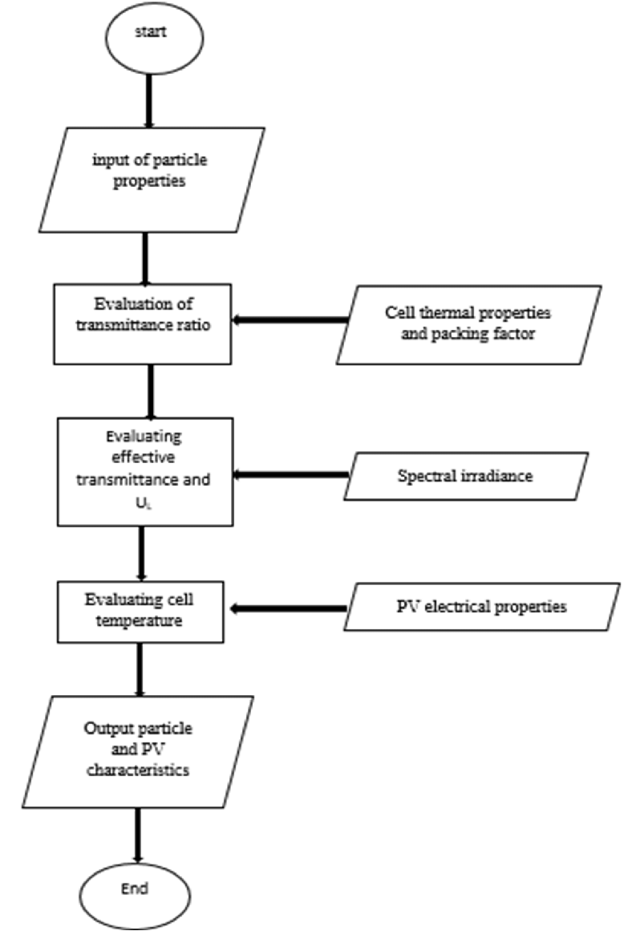

**User Stories**

|  |  |  |  |  |  |  |
| --- | --- | --- | --- | --- | --- | --- |
| **User Type** | **Functional**  **Requirement (Epic)** | **User Story**  **Number** | **User Story / Task** | **Acceptance criteria** | **Priority** | **Release** |
| Homeowner | **Installation Process** | USN-1 | As a homeowner, I want to install solar panels on my roof to reduce my electricity bills and decrease my carbon footprint. | The solar panel system must be installed and operational, providing a noticeable reduction in electricity bills. | High | Sprint-1 |
| business owner | **Energy Production Monitoring** | USN-2 | As a business owner, I want to invest in solar panels for my commercial property to lower operating costs and demonstrate my commitment to sustainability. | The solar panel installation should result in a significant decrease in the property's monthly energy expenses. | High | Sprint-1 |
| renewable energy enthusiast | **Maintenance Tracking** | USN-3 | As a renewable energy enthusiast, I want to monitor the real-time energy production of my solar panels through a mobile app to track their performance. | The mobile app should provide real-time data on solar panel energy production. | High | Sprint-2 |
| solar panel installer | **Integration with Utility Grid** | USN-4 | As a solar panel installer, I need a comprehensive checklist of materials and tools required for a solar panel installation job to ensure I have everything I need | The checklist should include a detailed list of all necessary materials and tools, organized in a logical sequence. | Medium | Sprint-1 |
| homeowner in a sunny region | **User Authentication and Access Control** | USN-5 | As a homeowner in a sunny region, I want to learn about available government incentives and tax credits for installing solar panels to make an informed decision about the investment | The information on government incentives and tax credits should be up-to-date and comprehensive | Medium | Sprint-1 |
| environmental advocate | **Government Incentives Information** | USN-6 | As an environmental advocate, I want to promote the benefits of solar energy to local communities through educational workshops and presentations | The educational materials and presentations should be engaging and informative | Medium | Sprint-1 |
| building contractor | **Solar Panel Estimation Platform** | USN-7 | As a building contractor, I want to include solar panel options in my construction projects to offer eco-friendly, energy-efficient homes to my clients. | Solar panel options should be seamlessly integrated into the construction process and meet the project's energy efficiency goals. | Medium | Sprint-2 |
| software developer | **Solar Farm Feasibility Study** | USN-8 | As a software developer, I want to create a user-friendly platform that allows homeowners to estimate the potential energy savings and environmental impact of installing solar panels on their properties. | The platform should be user-tested and refined to ensure ease of use and accurate calculations | Low | Sprint-1 |